**MANAGERIAL REPORT**

The following 3 managerial questions were generated to assist Adam, CEO of Cantech Solutions, in understanding his business to guide managerial decisions-making and initiatives better.

**Question 1: What does Cantech Solutions customer distribution look like, in terms of age, gender, and service use type?**

Answering this question will allow Adam to gain a better understanding of his customer profile and the behaviours of different customer segments. By knowing this, Adam can tailor marketing and strategic business decisions to align with the needs of specific customers based on specific age, gender, and service usage.

**SQL Query + Output: Age group distribution**

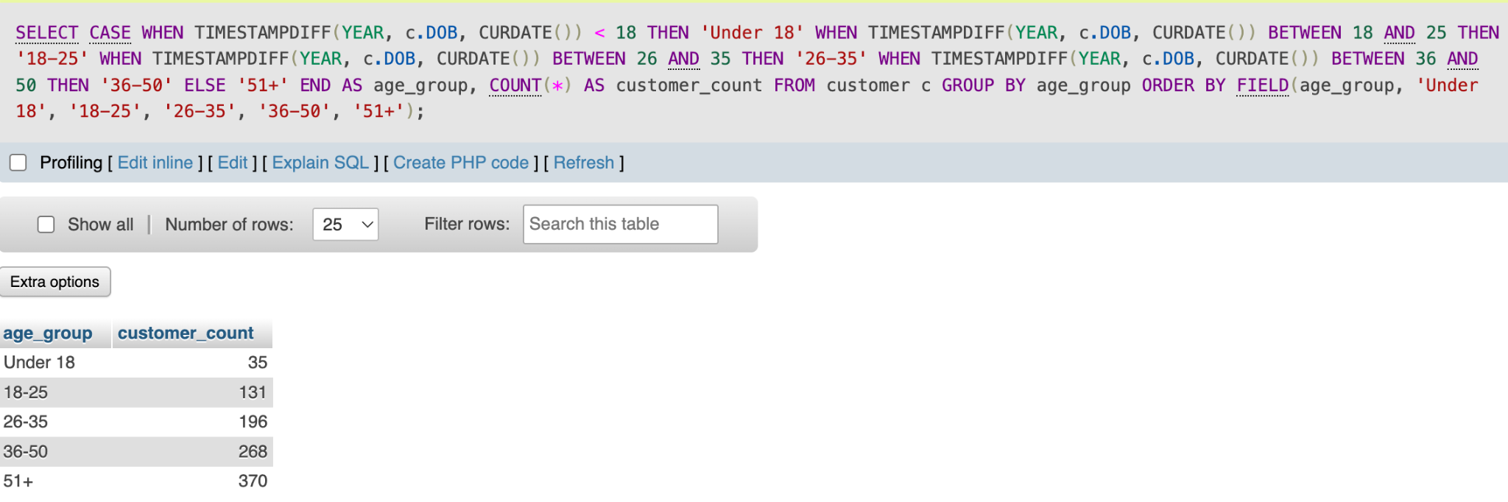

**SQL Query + Output: Gender based service use**

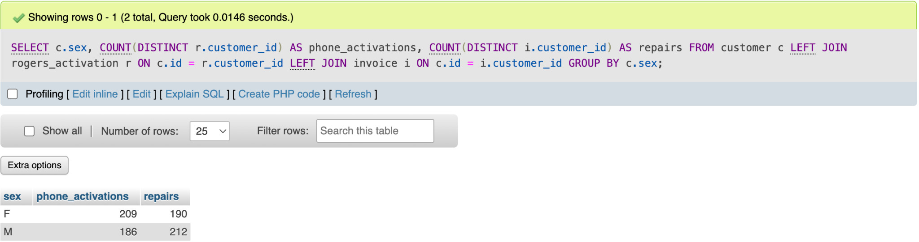

**SQL Query + Output: Percent of Cantech customers that are MoneyGram users**

**SQL Query + Output: Top 10 most active customers**

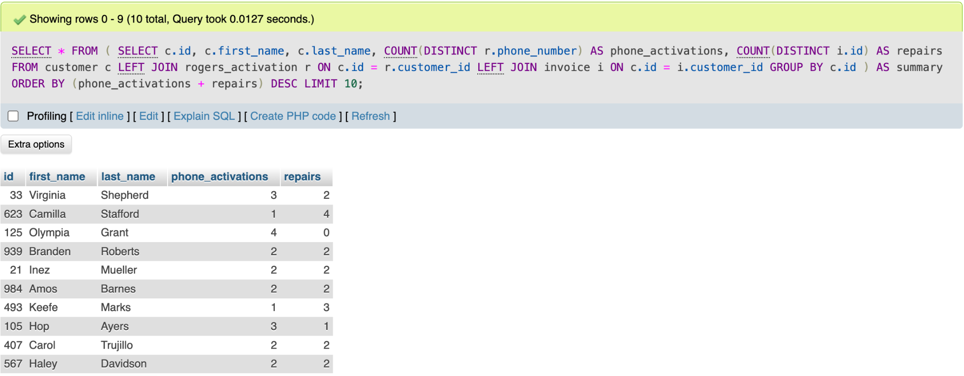

From the results it’s observed that most of Cantech Solutions' customers are 35+ years of age, indicating an older customer population. Around 32% of customers are in the 18–35 range, implying that younger individuals still find value in engaging with Cantech services but there’s room for growth. Female customers appear to engage more with phone activations than males (12% higher), while male customers prefer repair services. Moreover, 14.5% of customers are MoneyGram users, indicating more can be done to grow this service’s popularity. Adam can use all these insights to target specialized marketing initiatives for different demographics (i.e market rogers plan promotions to females).

The top 10 most active customers were also identified. This information can help Adam understand loyalty patterns and identify services that drive repeat engagement. Adam can use this data to pilot a customer loyalty program. For example, customers such as Roberts and Trujillo can get offered a 10% discount on their third repair. If the initiative is successful among the top 20–30 active customers, it can be expanded to all customers to promote retention. Incorporating such customer loyalty programs builds a sense of community and brand loyalty, helping Cantech differentiate themselves from its competitors.

**Question 2: What is the most common type of cell phone or laptop repair needed, and which parts do the repairs require?**

Answering this managerial question will allow Adam to effectively manage inventory, improve employee training, and design strategic marketing campaigns. By understanding which repairs and parts are most frequently used, Adam can proactively stock high-demand parts to eliminate repair time delays and also match training and promotions to most frequent repair-types.

**SQL Query + Output: Top 5 most common repairs**

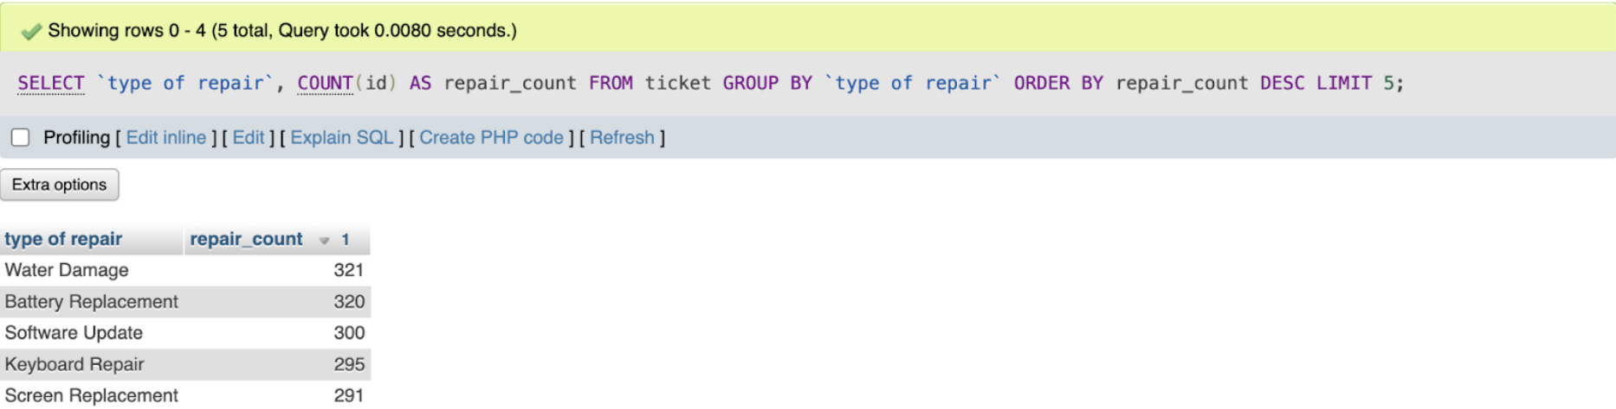

**SQL Query + Output: Most commonly replaced parts**

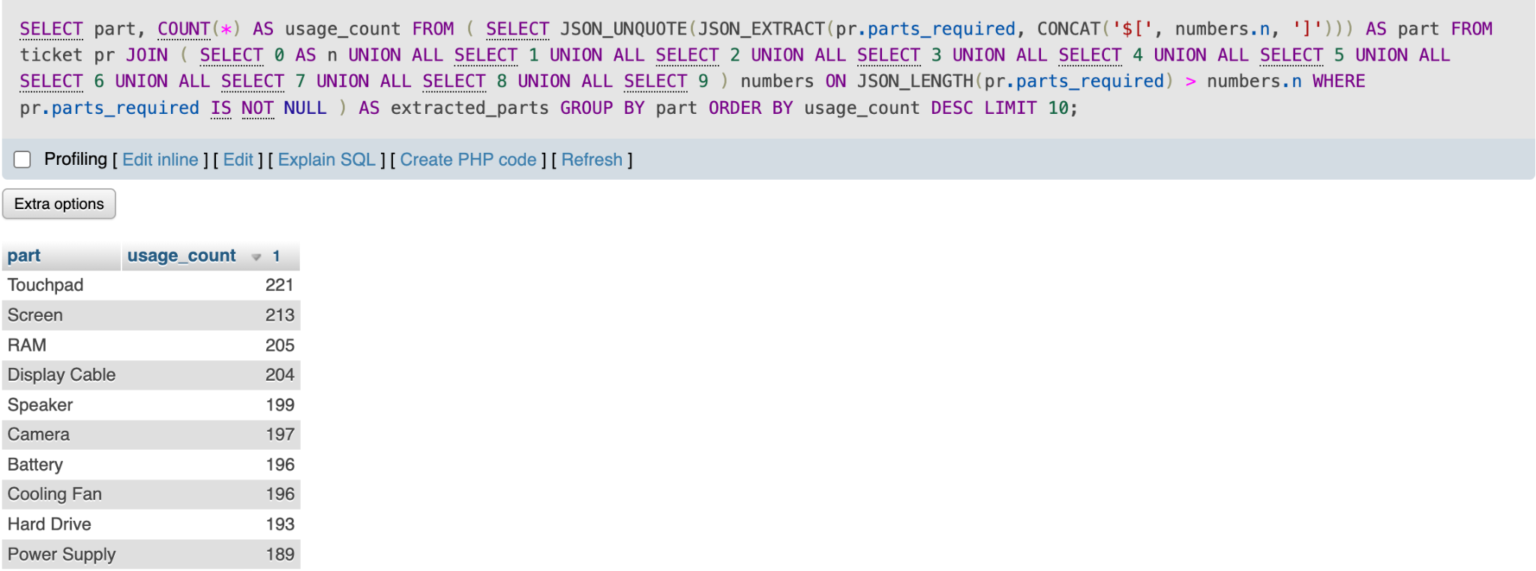

**SQL Query + Output: Most expensive repairs**

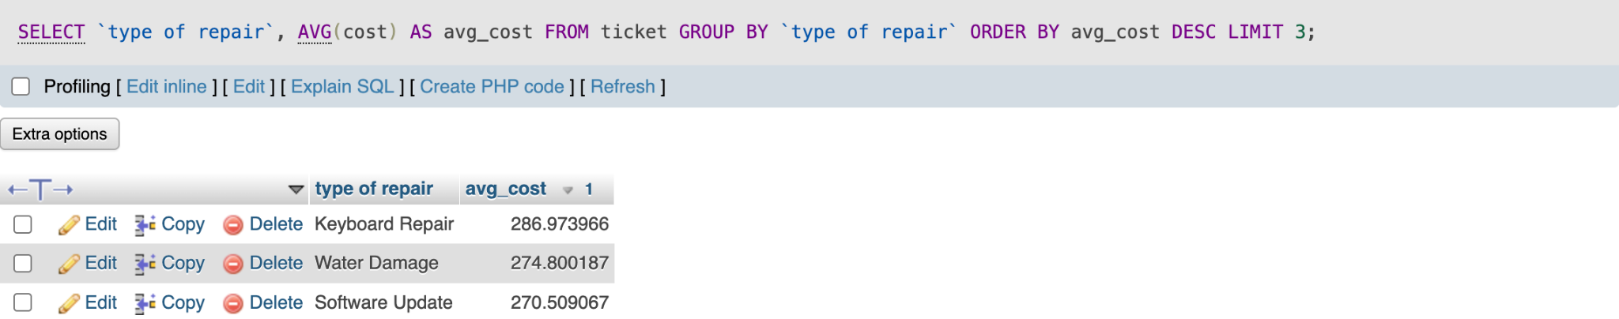

Water damage, battery replacement, software update, keyboard repairs, and screen replacements were identified as the top 5 most common repairs. The most frequently required parts are also reflective of this, with touchpads, screens and display cables highlighted as most frequently used. Stocking these high-demand parts will significantly increase repair turnaround time, as currently Adam orders parts on an as-needed basis from a wholesaler who takes up to 3 days to deliver.

Another interesting observation is made, that is, the top 3 most expensive repairs, (keyboard repairs, water damage, and software updates) are also in the top 5 most common repair types. This implies that the most frequent repairs are also the repairs that likely generate the highest margins. These expensive repairs are likely common as Cantech, being a small business, remains the cheaper option for customers compared to tech companies such as Apple or Best Buy. Therefore, Adam should prioritize marketing Cantech Solutions as a cost-effective, high-quality alternative to major brand repair centers. Furthermore, for customers that have engaged with these repairs, he can offer additional add-on services such as screen protection plans, or water-resistance checks on the basis that these services are expensive for the customer to experience again.

**Question 3: How many people activating plans with Rogers also purchase a phone, and which phones and plans are most popular?**

Cantech has a strong partnership with Rogers. Collecting data surrounding their success in providing Rogers services can strengthen this partnership and open doors for added collaboration. By analyzing phones and plans that are most popular, Cantech can negotiate commission rates and capitalize by selling their own products to Rogers customers.

**SQL Query + Output: Percent of customers who purchase a phone with Rogers activations**

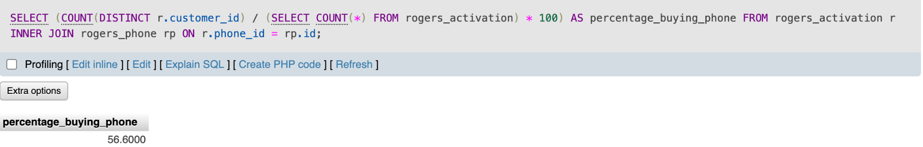

**SQL Query + Output: Top 5 most popular Rogers phones purchased**

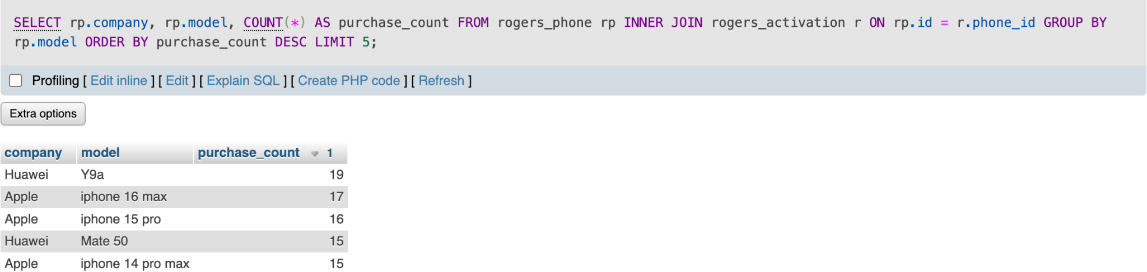

**SQL Query + Output: Most frequently activated plan type**

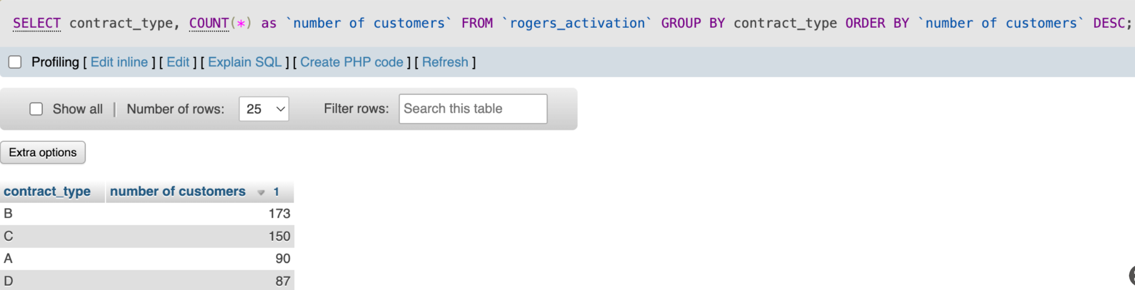

Looking at the query outputs, it’s noticed that just over half (56%) of customers that activate a Rogers plan at Cantech also purchase a phone. Of those that purchase a phone, the most popular selection appears to be Huawei and Apple phones, specifically the iPhone 14,15,16 max pro, Y9a, and Mate50. Adam should ensure that these phones are always in stock by asking Rogers to prioritize these particular phones when delivering inventory. Adam can also use this information to guide Cantech revenue generation, by negotiating higher commission rates for these particular phones with Rogers. The most common phone plans appear to be B and C. Both these plans are associated with premium-like features offered at a relatively affordable price, explaining their popularity.

With almost half of activations leading to phone purchases, it appears that many customers are willing/open to purchases during an activation. Adam can therefore begin strategic marketing initiatives to capitalize on activation services. For example, he can bundle popular phones with popular plans to boost the likelihood of both happening. He can further capitalize on Roger’s phone activations by pointing customers towards in-store products such as screen protectors and cases, and also market repair services for future reference.